6. JOB Application - Zoho Creator Command
Center Page

Aim:
To design and build a single internal "Command Center" Page in Zoho Creator for the existing
"Job Application" application, demonstrating the correct usage of all eleven Page Builder
elements (Panel, Board, Chart, Gauge, Search, Form, Report, Snippets, Button, Widgets, and
Viewer) so that the Loan Processing Cell has one unified workspace to monitor, manage, and act on loan application data.

Page Elements Used
Page Element Type | Element Name
Panel | Command_Center_Main_Panel
Board | Loan_Status_Board
Chart | LoanType_Popularity_Chart_Widget
Gauge | Loan_Disbursement_Target_Gauge
Search | Applicant_Search_Bar
Form | Quick_Counter_Loan_Form
Report | Full_Loan_Applications_Report
Snippets | Loan_Approval_Checklist_Snippet
Button | Send_Interview_Reminder_Button
Widgets | Disbursement_And_Interest_Rate_Widgets

Page Layout (Section-wise)
- Section 1: Overview Strip o Loan Disbursement Target Gauge (Gauge element) o Loan Type Popularity Chart Widget (Chart element) o Applicant Search Bar (Search element)
- Section 2: Processing Workspace o Send Interview Reminder Button (Button element) o Loan Status Board (Board element)
- Section 3: Detailed Data o Full Loan Applications Report (Report element)
- Section 4: Reference & Quick Actions (Sidebar) o Loan Approval Checklist Snippet (Snippets element) o PAN and Income
Certificate Viewer (Viewer element) o Quick Counter Loan Form (Form element, expandable tab)
- Section 5: Operations Strip o Disbursement Availability and Interest Rate Widgets (Widgets element)
- Note: All sections above are laid out within the Command_Center_Main_Panel, which serves as the single structural Panel wrapping the full page.

Screenshots:
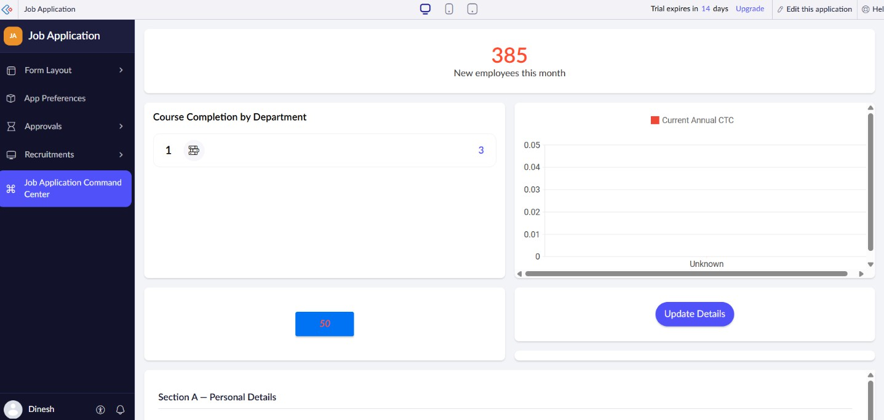

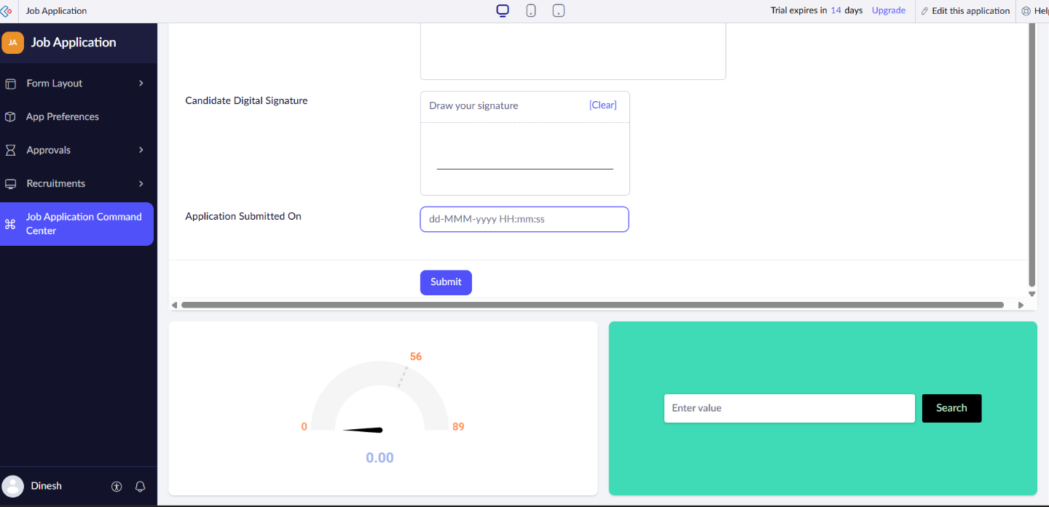

Result:
A single internal "Command Center" Page in Zoho Creator for the existing Job Application is created.

